Specification Sheet
version 20161110

KTA38-G5 Diesel Generator

Description
The KTA38-Series benefits from years of technical development and improvement to bring customers an innovative and future proof diesel engine that keeps pace with ever changing generator set requirements.
Recognized globally for its performance under even the most severe climatic conditions, the KTA38-Series is widely acknowledged as the most robust and cost effective diesel engine in its power range for the generator set market
Features
Aftercooler: Large capacity after cooler results in cooler, denser intake air for more efficient combustion and reduced internal stresses for longer life.
Fuel System: Cummins exclusive low pressure PT™ system with wear compensating pump and integral dual flyweight governor. Camshaft actuated fuel injectors give accurate metering and timing. Fuel lines are internal drilled passages in cylinder heads. Spin-on fuel filter.
Cooling System: Gear driven centrifugal water pump. Large volume water passages provide even flow of coolant around cylinder liners, valves and injectors. Bypass thermostats regulate coolant temperature. Spin-on corrosion resistors check rust and corrosion, control acidity and remove Impurities.
Cylinder Block: Alloy cast iron with removable wet liners. Cross bolt support to main bearing cap provides extra strength and stability.
Turbocharger: Cummins Turbo Technologies (CTT) exhaust gas driven turbocharger mounted at top of engine provides more power, improved fuel economy, altitude compensation, and lower smoke and noise levels.

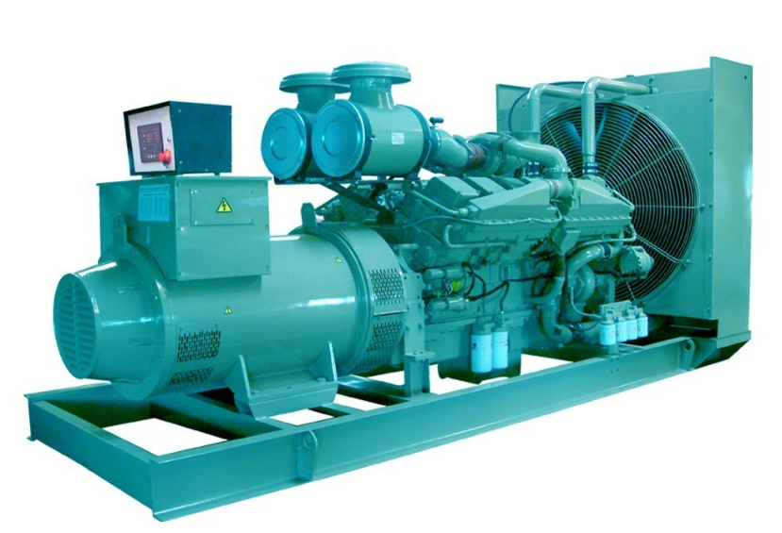
Ratings Definitions
Emergency Standby Power (ESP): Applicable for supplying power to varying electrical load for the duration of power interruption of a reliable utility source. Emergency Standby Power (ESP) is in accordance with ISO 8528. Fuel Stop power in accordance with ISO 3046, AS 2789, DIN 6271 and BS 5514.
Limited-Time Running Power (LTP): Applicable for supplying power to a constant electrical load for limited hours. Limited-Time Running Power (LTP) is in accordance with ISO 8528.
Prime Power (PRP): Applicable for supplying power to varying electrical load for unlimited hours. Prime Power (PRP) is in accordance with ISO 8528. Ten percent overload capability is available in accordance with ISO 3046, AS 2789, DIN 6271 and BS 5514.
Base Load (Continuous) Power (COP): Applicable for supplying power continuously to a constant electrical load for unlimited hours. Continuous Power (COP) in accordance with ISO 8528, ISO 3046, AS 2789, DIN6271 and BS 5514.
Product Specifications
 | KTA38-G5
Electrical Output (1500 rpm, 50 Hz) | Standby | Prime | Base
Gross engine output | 970 kWm | 880 kWm | 656 kWm
Net engine output | 937 kWm | 857 kWm | 633 kWm
Typical generator output | 880 kWe / 1100 kVA | 800 kWe / 1000 kVA | 600 kWe / 750 kVA
Fuel Consumption (1500 rpm, 50 Hz)
Full load (100%) | 970 kWm | 880 kWm | 656 kWm
Half load (50%) | — | 440 kWm | —
Quarter load (25%) | — | 220 kWm | —
General Engine Data
Type | 4 cycle, Turbocharged and After-cooled
Bore | 159 mm
Stroke | 159 mm
Displacement | 38 L
Cylinder block | 12-cylinder,direct injection, 4-cycle diesel engine
Battery charging alternator | 35A
Starting voltage | 24V
Fuel system | Direct injection, EFC (Electric Fuel control) governor
Fuel filter | Dual spin on paper element fuel filters with standard water separator
Lube oil filter type | Spin on full flow filter
Lube oil capacity | 140 L
Flywheel dimensions | SAE 0
Cooling Performance Data
Cooling System Design | JWAC
Coolant Ratio | 50% ethylene glycol; 50% water
Total Coolant Capacity | 218.5 L
Limiting Ambient Temperature | 50°C
Fan Power | 20 kWm
Cooling System Air Flow | 18.9 m³/s
Air Cleaner Type | Dry replaceable element with restriction indicator
Weight & Dimensions
Length | 3172 mm
Width | 1752 mm
Height | 2004 mm
Weight (dry) | 4990 kg

Ratings Definitions
Emergency standby power (ESP):
Applicable for supplying power to varying electrical load for the duration of power interruption of a reliable utility source. Emergency Standby Power (ESP) is in accordance with ISO 8528. Fuel Stop power in accordance with ISO 3046, AS 2789, DIN 6271 and BS 5514.
Limited-time running power (LTP):
Applicable for supplying power to a constant electrical load for limited hours. Limited Time Running Power (LTP) is in accordance with ISO 8528.
Prime power (PRP):
Applicable for supplying power to varying electrical load for unlimited hours. Prime Power (PRP) is in accordance with ISO 8528. Ten percent overload capability is available in accordance with ISO 3046, AS 2789, DIN 6271 and BS 5514.
Base load (continuous) power (COP):
Applicable for supplying power continuously to a constant electrical load for unlimited hours. Continuous Power (COP) in accordance with ISO 8528, ISO 3046, AS 2789, DIN 6271 and BS 5514.

Certifications
This engine has been built to comply with CE certification.
This engine has been designed in facilities certified to ISO9001 and manufactured in facilities certified to ISO9001 or ISO9002.

Cummins G-Drive Engines
Asia Pacific
10 Toh Guan Road #07-01
TT International Tradepark
Singapore 608838
Phone 65 6417 2388
Fax 65 6417 2399

Europe, Middle East, Africa
Manston Park Columbus Ave
Manston Ramsgate
Kent CT12 5BF. UK
Phone 44 1843 255000
Fax 44 1843 255902

Latin America
Rua Jati, 310, Cumbica
Guarulhos, SP 07180-900
Brazil
Phone 55 11 2186 4552
Fax 55 11 2186 4729

Mexico
Cummins S. de R.L. de C.V.
Eje 122 No. 200 Zona Industrial
San Luis Potosí, S.L.P. 78090
Mexico
Phone 52 444 870 6700
Fax 52 444 870 6811

North America
1400 73rd Avenue N.E.
Minneapolis, MN 55432 USA
Phone 1 763 574 5000 USA
Toll-free 1 877 769 7669
Fax 1 763 574 5298

